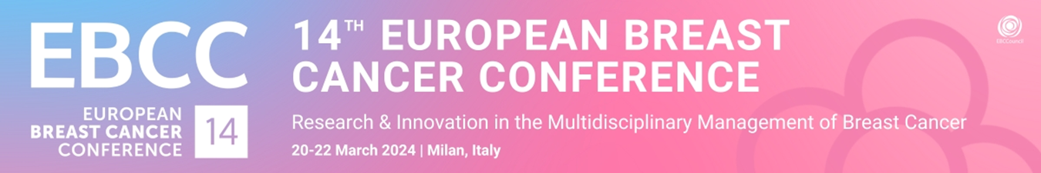
Satellite Symposia FINAL Programme
Please complete this document and send it to ebcc@eortc.org by 09.02.2024 at the latest.
Company Name:
Satellite Symposia Title (final version):
Date: (Please select) 20.03.2024 / 21.03.2024 / 22.03.2024 always at 12:45-13:45
Room: (Please select) Red / Blue / Yellow
Speaker & Presentation details: (Please fill in everything)

Presentation start time | Presentation stop time | Presentation Title | Presenter Name | Presenter Affiliation | Country
12:45 | 13:00 | - Lorem ipsum dolor sit amet, consectetur adipiscing elit. | Joe Bloggs | Example Hospital | BELGIUM
13:00 | 13:15 | - Lorem ipsum dolor sit amet, consectetur adipiscing elit. | Joe Bloggs | Example University | ITALY
13:15 | 13:30 | - Lorem ipsum dolor sit amet, consectetur adipiscing elit. | Joe Bloggs | Example Inc | GERMANY
13:30 | 13:45 | - Question & Answer session

Satellite Symposium Mailing Specifications

A one-time email blast will be sent to all EBCC-14 registered delegates promoting all Satellite Symposia. Content for this e-blast must be submitted by 09 February 2024.

- Promotion text of max 100 words.
- Incl. maximum one link to website relevant to Satellite Symposium programme.
- Note that the link may not direct to drug promotion.
- Including maximum one image/banner of 600 width/200 height
- Failure to submit content at the deadline or according to the given specs will mean no mailing will be sent out on behalf of the Satellite Symposium organiser. Repeat e-blasts will not be allowed.

Add here your image/banner of 600 width/200 height:

Promotion text of max. 100 words:
………………………………………………………………………………………………………………………………………………………………………………………………………………………………………………………………………………………………………………………………………………………………………………………………………………………………………………………………………………………………………………………………………………………………………………………………………………………………………………………………………………………………………………………………………………

